Washington, D.C. Trip Reminder
One of our traditions at CES is the annual Sixth Grade Trip to Washington, D.C. CES students have been taking this trip to our Nation’s Capital for over 20 years and it has made great memories for all involved. An informational meeting will be held Monday, October 16, at 6pm in the CES library for all students and parents interested in learning more about the trip. The meeting will last about an hour and cover the tentative itinerary, costs, and procedures.
Parents of sixth graders intending to take the sixth grade trip to Washington, D.C. are reminded that the initial payment along with the Commitment and Permission form are due by 11/3/17. It is important to know how many people are planning on taking the trip. Please make checks out to: “CES 6th grade trip.”
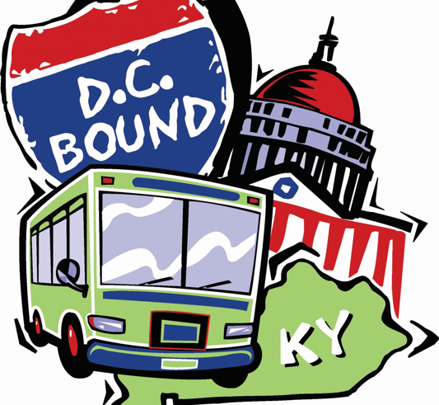

Save the Date:
10-6-17 Oriole Strong Event
10-11-17 1:45 Dismissal
10-12-17 Picture Retakes
10-??-17(TBD) (VB) Oriole Strong Event
10-12-17 Board Meeting 7pm
10-16-17 Bus Evacuation Drills
10-16-17 6pm DC Trip Meeting
10-17-17 End of First Quarter
10-19-17 9am Flu Clinic
10-19-17 Great American Shake Out Day
10/23-10/27 Red Ribbon Week
10-25-17 P/T Conferences CES
10-26-17 P/T Conferences CES
10-26-17 Saving Smiles
10-26-17 Health Screening
10-27-17 No School
10-31-17 Fall (Halloween) Parties

How to change transportation:
If you want to change your child’s way of getting home, please send a signed and dated note in the planner or a separate sheet of paper. We encourage parents not to change the transportation at the last minute on the phone except in emergencies. When we are not certain, and don’t have a signed and dated not, we will err on the side of caution and stick with the normal means of transportation.

Red Ribbon Week Announcement
Parents,
CES student Council, led by Miss Ohmart and Mrs. Bredehoeft, are excited to announce that the week of: October 23-27 will be Red Ribbon Week. We will take time to recognize the importance of being drug and alcohol free. Look for more details on what the week will entail on the web site and CES Facebook page.

Parent Teacher Conferences
On October 25 and 26, parents and teachers have the opportunity to visit about their student’s academic and social progress. This year, the meetings will be scheduled for Wednesday, October 25 and Thursday, October 26 from 4:00 until 7:30 pm. Parents should look for a note with their meeting time listed. If you have a problem and need to change your meeting, contact Mrs. Paterson in the CES Office.

5th and 6th Grade Basketball
Girls will practice Mondays and Wednesdays, beginning after Thanksgiving.
Boys will practice Tuesdays and Thursdays, beginning after Thanksgiving.
Practices will run from 3:30-5:00.
All athletes must have a physical on file before being eligible to practice. There will be a coach/parent meeting prior to the start of the season, date TBD.

Physicals needed for 5th and 6th grade sports
This is a reminder that all students participating in 5th & 6th grade basketball and cheerleading need to have a sports physical on file before they will be allowed to participate in practices. The form is available at most medical offices and can be downloaded here: https://www.mshsaa.org/resources/pdf/PreParticipationPhysicalEvaluation_1617.pdf. This is the same form used by junior and senior high athletes. Basketball and cheer practices will begin after Thanksgiving break.

PTO Boxtops Promo
The Parent Teacher Organization has again decided to run the Boxtops 4 Education program. Students and parents are asked to clip and save and turn in Boxtops. Each Boxtops coupon is worth 10¢ to our school. Last year, we collected enough coupons to earn over $1,500! The collection period has already began. You can find out what products have Boxtops at www.boxtops4education.com From time to time, we will send home Boxtops collection pages to make collecting easy or you can just drop your Boxtops in a baggie and send them to school with your student anytime.
Halloween Information
Halloween parties will take place at CES on Tuesday, October 31. Students that plan on wearing a costume need to bring them in a bag as they are not to wear them to school. Knives, swords, guns or other items are not generally allowed at school and should be left at home. Face paint and other make up take too long to apply at school and should be left at home as well. All costumes must otherwise comply with the school dress code.
Some classes have room parents help with the festivities, others do not. Please contact your child’s teacher to find out if parental help is needed. Room parents are to enter through the front doors and sign in. Parents will be allowed to go to the classrooms at 1:45pm. Parties will begin no earlier than 2:00pm. Some classrooms may choose to begin their parties at a later time. Room parents bringing snacks for parties are reminded to bring healthy treats and try to avoid sugary snacks.

Congratulations to the following hard working students who worked very hard and ran for Student Council. You can’t all win, but you are all winners and we’re proud of you:
The candidates for officer gave their speeches to their teachers and peers who all assembled together in the library from 4th, 5th, and 6th grades. After the speeches, all students voted.
President: Hannah Goolsby, Kiya Inman, and Dillon McGinnis
VP : Ava Hemme
Secretary : Lilly Wycoff and Faith Moore
Treasurer: Chloe Johnson, Olivia Rolf, and Wyatt Oliveros

Representatives – 6th grade: Jacey Jolly
Representatives 5th Grade – Aaron Brown, Kellen Fiene, Olivia Hemme, Veronica Hooper, Rinley Hulver, Kaitlyn King, Landon Langkrahr, Celissa McCurdy, Jackson McManus, Kali Moulton, Brayden Reid, and Emily Wilkins
Representatives 4th Grade – Jenesis Diamond, Brooklyn Garrison, Tabitha Lynn, Alex Oetting, and Dakota Reynolds

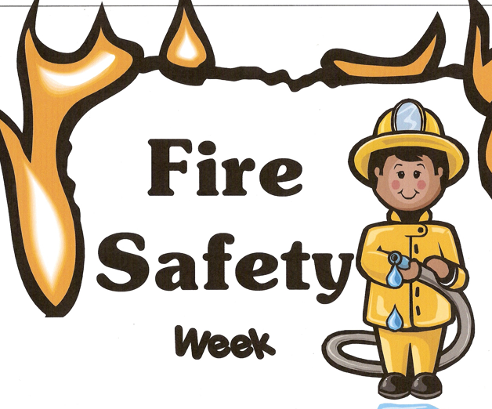

Fire Prevention Week
The week of 10/9-10/13 at CES we will be observing Fire Prevention and Safety Week. The week will culminate with a presentation by the Concordia Fire Department. We encourage you all to discuss this at home and consider your own emergency plans in the event of a fire.

Health Fair is Thursday, October 26
All students will be checked for weight, height, vision, and hearing. Sixth grade students will be screened for scoliosis. Results of the screenings will be recorded in the student’s file and will be provided to the parents within three weeks of screening.

Singing Orioles
Singing Orioles is a talented group of 4th, 5th, and 6th grade students who enjoy singing and choose to spend extra time after school once a week to learn challenging music. The group meets in the music room and is sponsored by Mrs. Brown. Singing Orioles releases to the front parking lot at 4:15 every Tuesday afternoon.
Singing Orioles will meet during first semester only. During second semester, 5th and 6th grade students will have the opportunity to continue singing if they try out for the West Central District 5th and 6th Grade Honor Choirs. If your child would like to be in Honor Choir, Mrs. Brown strongly encourages him or her to also be a member of the Singing Orioles. Although membership in Singing Orioles does not guarantee a position in the honor choir, students in Singing Orioles will have a head start with part-singing, score reading, and a host of other choir techniques.

